|  |  |
| --- | --- |
| **FORMAL LETTER** | **INFORMAL LETTER** |
| **Official** | **Friendly** |
| Prescribed format | No prescribed format |
| NO colloquial words, abbreviations, NO short forms  As soon as possible; I would... | Friendly and casual language    ASAP, I´d... |
| SUBJECT LINE – very important | Subject line – not required |
|  |  |
|  |  |
| 1. Sender´s address - vpravo hore | 1. Sender´s address |
| 1. Date - 30 June 2024 (no numbers only) | 2. Receiver´s address |
| 1. Receiver´s address - vľavo hore | 3.Date |
| 1. The subject of the letter – 1 line   Subject: Invoice nr./ Order nr. | ------- |
| 1. Salutation   Dear Sir/Madam, Mr. Ms. Brown | 4.Salutation  Dear David |
| 1. Body – 3 paragraphs 2. introduce yourself + the purspose of writing the letter   I am Peter Stevenson and I am writing regarding your article, advertisement, letter   1. give detail of the mater   Pleased find attached a pdf file...   1. conlude by mentioning what   you expect  Please consider the issue and find  solution at the earliest. | 5.Body – 3 paragraphs  1. beginning  Thanks for your letter.  Sorry I haven´t written for ages.  How´s everything going?  How are you? Hope you are well.  It was lovely to hear from you.  2.main content  I´m writing to tell you...  I´ve attached.....  3.ending  Thanks lot |
| 1. Complimentary closing   I would like to thank you in advance.  Yours faithfully,  Yours sincerely, | 6. Commonly used phrases  Hope to see you soon!  Lots of love, Best wishes,  Best regards, Love, Kindly, Warm Regards, |
| 1. Sender´s name, signature | 7. Sender´s name, signature |

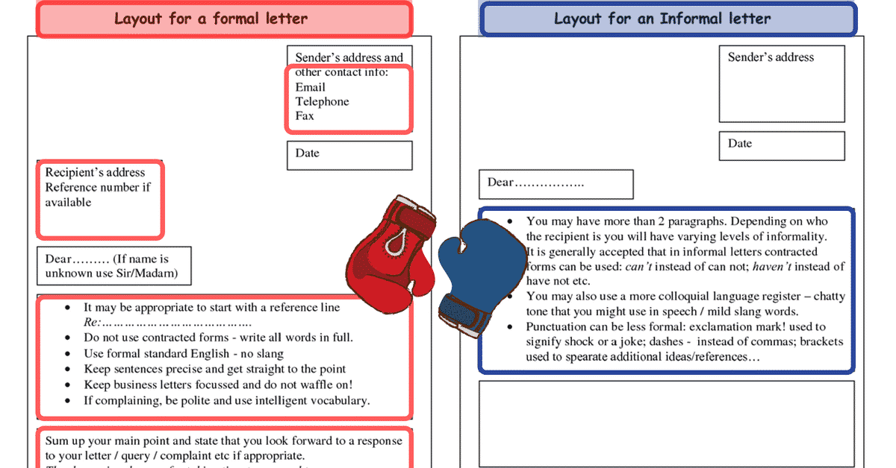

**EXAMPLE OF A FORMAL LETTER**

DIPS  
Rohini  
New Delhi 1100

20 January 2024

The proprietor  
Apple Inc.  
126, Nehru Place  
New Delhi 1100XX

Subject: Placement of an order for computers and their accessories

Dear Sir,

This is to inform you that our school management has decided to place an order with your company for the supply of computers and computer accessories. The list of items is given below. All the products should be genuine. The price quotation submitted by your agents has been approved and the institutional discount of 10% offered by you has been accepted.  
Kindly make it convenient to send the delivery within 15 days of the issue of this letter. I am sure the proper packing of the computers will be taken care of and any responsibility for the damage caused during transportation shall rest with you. I hope future repairs and maintenance of the items will also be provided by you promptly and satisfactorily. The payment will be made through a crossed cheque to your agent within a month of delivery.

**No. of Items** 25  
  
Yours faithfully,  
Neha Singh  
(Head of Computer Department)

**EXAMPLE OF AN IFORMAL LETTER**

(B-32, sector-11

Rohini

New Delhi-110085)

(adresa nemusí byť)

March 15, 2021

Dear Muskan,

How have you been? I hope my letter finds you in best of health and spirits. It has been almost a month since I transferred to the boarding school. I´m very happy in my new school. The classes and dormitories are very spacious. There are well equipped science laboratories and a library with a great collection of books. The school has amazing sports facilities such as swimming pool, horse riding track and archery range.

I believe my life here will be interesting and enjoyable. Although I´ve made many new friends, I still miss you and the other friends. Please, pay my regards to your parents.

Kind regards

Aakriti/ Abhinav

**TASK 1. Write a letter to the university that required the copy of your**

**final exam.**

**TASK 2. Write a letter to your friend describing your last school trip.**